Task Procedure for ALICE

[ Task Procedure = simplified version of the Specific Plan for Health and Safety, adapted for ALICE Collaboration. - PPSPS = Plan Particulier de Sécurité et de Protection de la Santé ]

Task to be realized Commissioning of TPC with FEE and HV
Location of work SXL2, clean room
Dates of work start 1.4.06 end 31.08.06

Sub-project TPC Institute GSI Darmstadt+Univ.HD+CERN
Sub-project Leader Peter Braun-Munzinger phone 71469
Safety link-person Peter Glassel phone 16 3426
Work-Package Engineer Peter Glassel phone 16 3426
Local Work supervisor Joachim Baechler phone 16 4106
Experimental-Area Manager Sébastien Evrard/Pieter Ijzermans phone 16 4821 / 16 4168

Persons involved Luciano Musa task, qualification physicist
Roberto Campagnolo physicist
Lennart Osterman technician
Joachim Baechler physicist
Hansake Gustafsson physicist
Claude Engster engineer
Antoine Junique technician
Bjorn Halvor Straume physicist
Joachim Baechler physicist
Chilo Garabatos physicist
Peter Glassel physicist
Uli Frankenfeld physicist
Rok Pestotnik physicist
Sorina Popescu physicist
Marco Boccioli physicist
Hans Rudolf Schmidt physicist
Klaus Schossmaier physicist
Pierre Vande Vyvre physicist
Jens Wiechula physicist
Jean-Claude Labbe technician

Brief description of work procedure
Commissioning of all 36 readout sectors of the TPC:
1 Connecting and operating LV, HV, DDL, DCS 2.
2. Water cooling for each sector (one or 2 sectors at a time).
3. Water cooling for resistor rods
3. Operating the drift HV (100 kV)
4. Operating the ROC HV (up to 1.6 kV)
3. Use of laser system to produce tracks
Access to sectors is from scaffolding.

Detailed description (step by step) of the work procedure | Risk assessment | Preventive measures (collective),
Cabling and uncabling sectors | work on scaffold | Regular scaffolding with barriers. Changes of scaffolding beyond moving them on the floor will be certified by B. Moris
Application of drift HV = 100 kV | electrical shock | no risk: fully shielded inside TPC. DCS control. TPC shell is grounded.  HV warning sign at entrance.
Application of ROC HV up to about 1600 V | electrical shock | no risk: fully shielded inside TPC  HV warning sign at entrance.
Operation of FEE and low voltage power supplies (<10 V) | fire | fire alarm system
Water cooling (HV rod and FEE cards) | water leak | - Underpressure system, no leakage as long as underpressure is there.  - The water is in closed circuit with only a limited amount (<100 l) in the system which could be easily taken by the draining system of the clean room in case of failure
Operation of TPC with Ne/CO2 and CO2 | leak and suffocation | O2-detectors AND CO2-detctors to be carried by persons inside clean room

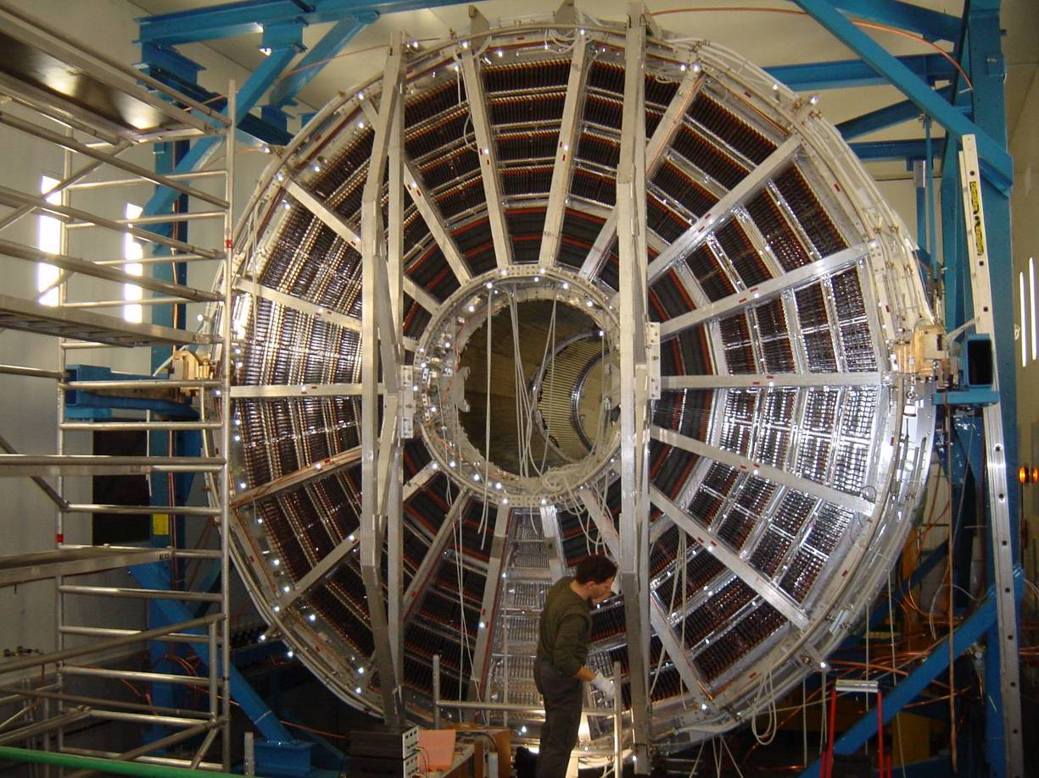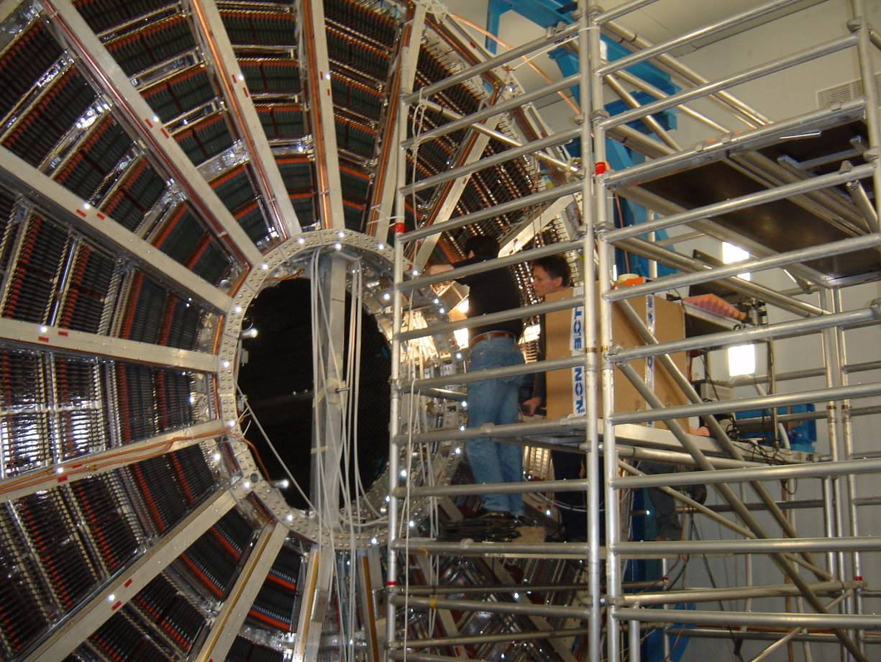
Responsibility

The Work-Package Engineer is responsible of this procedure.

The Work-Package Engineer and the Work-Package work supervisor certify that the persons involved have the proper qualifications and have been properly informed about safety aspects of the work.

WPE Peter Glassel ………….. date ………………….

WPWS Joachim Baechler …………. date ………………….

Approval

E.A.M. (also TSO) Sébastien Evrard date …………... ...................................
16 4821
Safety Coordinator Emmanuel Paulat date …………... ………………………
16 3870

TS Transport Coord. Jacky Bernard date …………... ………………………
16 0583

If needed, also sent to:

Integration & Installation Coordinator, Lars Leistam 16 0551

GLIMOS Marc Tavlet 16 0217 ou 70608

Commissioning Coordinator
(and Deputy Glimos), Hans Taureg 16 0359

SC Inspector Hervé Buret 16 0013

This task procedure must be on display at the place of work.

