Task Procedure for ALICE

[ Task Procedure = simplified version of the Specific Plan for Health and Safety, adapted for ALICE Collaboration. - PPSPS = Plan Particulier de Sécurité et de Protection de la Santé ]

Task to be realized Commissioning of Laser system of TPC
Location of work SXL2, clean room
Dates of work start 15.4.06 end 31.08.06

Sub-project TPC Institute GSI Darmstadt+Univ.HD+CERN
Sub-project Leader Peter Braun-Munzinger phone 71469
Safety link-person Peter Glassel phone 16 3426
Work-Package Engineer Peter Glassel phone 16 3426
Local Work supervisor Borge Svane Nielsen phone 16 4221
Experimental-Area Manager Sébastien Evrard/Pieter Ijzermans phone 16 4821 / 16 4168

Persons involved Borge Svane Nielsen physicist
Jorn Westergaard technician
Erik K. Olsen technician
Gael Renault physicist
Jens J. Gaardhoje physicist
Niels Lindegaard technician Joachim Baechler physicist
Jean-Claude Labbe technician

Brief description of work procedure
- Setting up and operating a class 4 UV-laser (266 nm) with
- The beam line connecting it to the TPC on the clean room floor.
- Alignment of the laser component on both end plates
- Operation of the laser together with FEE readout

Detailed description (step by step) of the work procedure | Risk assessment | Preventive measures (collective),
Setting up of laser | UV exposure of eyes, skin | Only people with safety goggles and laser safety training allowed in clean room while setting up.
Routine operation of laser | UV exposure of eyes, skin | no risk: beam fully shielded with beam tubes. Laser itself in protection cover. No goggles needed in this phase.  Warning signs at clean room entrance. Flashing sign during operation.
Alignment of laser optics on end plates | work on scaffold | Regular scaffolds with barriers. Changes of scaffolding beyond moving them on the floor will be certified by B. Moris  Not more than 2 people on one scaffold level.
Water cooling of laser | water leak | No risk: small flow, sink existing. Cooling only on while in operation. No operation without people present.
Operation of TPC with Ne/CO2 and CO2 | leak and suffocation | O2-detectors AND CO2-detctors to be carried by persons inside clean room

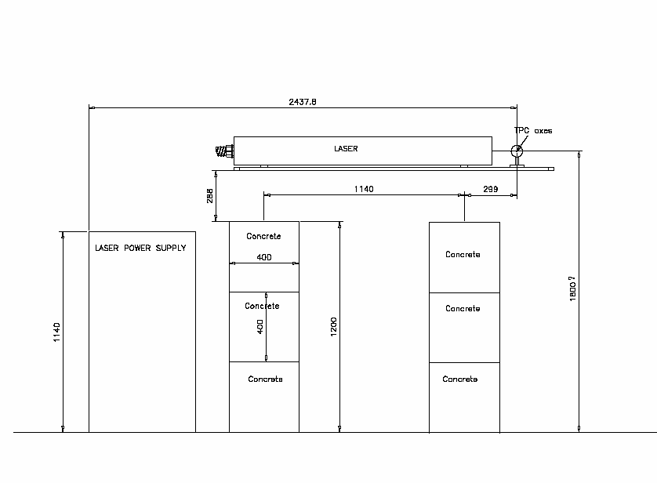
Side and top view of laser 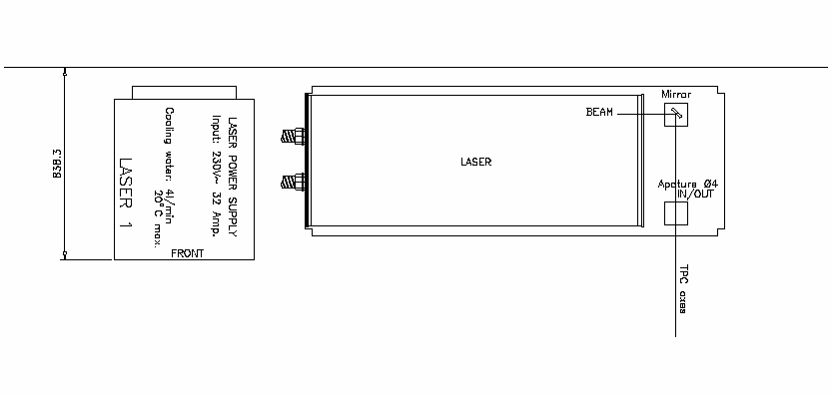
Responsibility

The Work-Package Engineer is responsible of this procedure.

The Work-Package Engineer and the Work-Package work supervisor certify that the persons involved have the proper qualifications and have been properly informed about safety aspects of the work.

WPE Peter Glassel ………….. date ………………….

WPWS Joachim Baechler …………. date ………………….

Approval

E.A.M. (also TSO) Sébastien Evrard date …………... ...................................
16 4821
Safety Coordinator Emmanuel Paulat date …………... ………………………
16 3870

TS Transport Coord. Jacky Bernard date …………... ………………………
16 0583

If needed, also sent to:

Integration & Installation Coordinator, Lars Leistam 16 0551

GLIMOS Marc Tavlet 16 0217 ou 70608

Commissioning Coordinator
(and Deputy Glimos), Hans Taureg 16 0359

SC Inspector Hervé Buret 16 0013

This task procedure must be on display at the place of work.

